EC-231 Operating Systems
BS(CE)-2021
LAB REPORT # 6

Submitted By:
Reg. No. | Name
21-CE-009 | Huzaifa Shahbaz
21-CE-020 | Muhammad Ibthesam
21-CE-021 | Yawar Ali Malik

Department of Computer Engineering
BS Computer Engineering Program
HITEC University Taxila
 | Presentation  (Format (0.5) + Title (0.5) +  Conclusion(1) + Procedure(2) + Objective(1)) | Calculation/Coding | Observation/ Program Results | Total
Total | 5 | 5 | 5 | 15
Obtained

__________________________
Lab Instructor.
Engr. Fasih Ahmad

Experiment #6
Implementation of File I/O Redirection System Calls in Linux-I
Objective: In this lab we will learn about system call techniques in UNIX.

Software Used: 1. Ubuntu 2.GCC complier 3. Sublime text 4.Text editor

Procedure: System Call: System calls are commands that are executed by the operating system. "System calls are the only way to access kernel facilities such as file system, multitasking mechanisms and the inter-process communication primitives. File Structure related System Calls: • create() • open() • read() • write() • close() 1.File Descriptors: A file descriptor uniquely identifies an open file of the process. Some file descriptor values are reserved for system uses. File descriptor is integer that uniquely identifies an open file of the process. 2.File Descriptor table: File descriptor table is the collection of integer array indices that are file descriptors in which elements are pointers to file table entries. One unique file descriptors table is provided in operating system for each process. 3.File Table Entry: File table entries is a structure In-memory surrogate for an open file, which is created when process request to opens file and these entries maintains file position. 4.Standard File Descriptors: When any process starts, then that process file descriptors table’s fd(file descriptor) 0, 1, 2 open automatically, (By default) each of these 3 fd references file table entry for a file named /dev/tty /dev/tty: In-memory surrogate for the terminal Terminal: Combination keyboard/video screen Read from stdin => read from fd 0 : Whenever we write any character from keyboard, it read from stdin through fd 0 and save to file named /dev/tty.Write to stdout => write to fd 1 : Whenever we see any output to the video screen, it’s from the file named /dev/tty and written to stdout in screen through fd 1.Write to stderr => write to fd 2 : We see any error to the video screen, it is also from that file write to stderr in screen through fd 2. PERMISSIONS/MODE: Every file in unix has permissions, that is, which all users can read(r)/write(w)/execute(x) the file.These are often represented using octal numbers: In 0abc, a corresponds to the permissions of the owner, b corresponds to the permissions of the group, c corresponds to the permissions of others. SYSCALLS: System call are those that the services of the operating system to the user programs via Application Program Interface(API). The different I/O syscalls used here, include: 1. Creat: Used to Create a new empty file. Syntax in C language: int creat(char *filename, mode_t mode) Parameter: 1.filename : name of the file which you want to create 2. mode : indicates permissions of new file. Returns: 1.return first unused file descriptor (generally 3 when first create use in process because 0, 1, 2 fd are reserved) 2.return -1 when error How it work in OS 1.Create new empty file on disk 2.Create file table entry 3.Set first unused file descriptor to point to file table entry 4. Return file descriptor used, -1 upon failure Purpose Creates an empty file at path filename with permissions mode and returns the file descriptor that points to that file in the file table entry. In case of any error, it returns -1. 2. Open: Used to Open the file for reading, writing or both. Syntax in C language: #include<sys/types.h> #include<sys/stat.h> #include <fcntl.h> int open (const char* Path, int flags [, int mode ]); Parameters: 1. Path: path to file which you want to use absolute path begin with “/”, when you are not work in same directory of file.Use relative path which is only file name with extension, when you are work in same directory of file.

1. flags : How you like to use 2. O_RDONLY: read only, O_WRONLY: write only, O_RDWR: read and write, 3.O_CREAT: create file if it doesn’t exist, O_EXCL: prevent creation if it already exists How it works in OS 1.Find the existing file on disk 2. Create file table entry 3. Set first unused file descriptor to point to file table entry 4. Return file descriptor used, -1 upon failure Purpose: Open the file at path Path with the flags flags and permissions mode and returns the file descriptor that points to that file in the file table entry. In case of any error, it returns-1. 3. Close: Tells the operating system you are done with a file descriptor and Close the file which pointed by fd. Syntax in C language #include <fcntl.h> int close(int fd); Parameter: fd :file descriptor Return: 1. 0 on success. 2. -1 on error. How it works in the OS: 1. Destroy file table entry referenced by element fd of file descriptor table – As long as no other process is pointing to it! 2.Set element fd of file descriptor table to NULL Purpose: Close the file. It returns 0 once the file is closed successfully and -1 in case of any error. 4. Read: From the file indicated by the file descriptor fd, the read() function reads cnt bytes of input into the memory area indicated by buf. A successful read() updates the access time for the file. Syntax in C language: #include<fcntl.h> size_t read (int fd, void* buf, size_t cnt); Parameters: 1. fd: file descriptor 2. buf: buffer to read data from 3. cnt: length of buffer Returns: How many bytes were actually read 1. return Number of bytes read on success 2. return 0 on reaching end of file 3. return -1 on error
4. return -1 on signal interrupt Important points: 1. buf needs to point to a valid memory location with length not smaller than the specified size because of overflow. 2. fd should be a valid file descriptor returned from open() to perform read operation because if fd is NULL then read should generate error. 3. cnt is the requested number of bytes read, while the return value is the actual number of bytes read. Also, some times read system call should read less bytes than cnt. Purpose: Read data upto count bytes from a file whose file descriptor is fd and store the results in buf pointer. It returns the number of bytes read. In case of any error, it returns -1.. 5. Write: Writes cnt bytes from buf to the file or socket associated with fd. cnt should not be greater than INT_MAX (defined in the limits.h header file). If cnt is zero, write() simply returns 0 without attempting any other action. Syntax in C language: #include <fcntl.h> size_t write (int fd, void* buf, size_t cnt); Parameters: 1. fd: file descriptor 2. buf: buffer to write data to 3. cnt: length of buffer Returns: How many bytes were actually written 1. return Number of bytes written on success 2. return 0 on reaching end of file 3. return -1 on error 4. return -1 on signal interrupt Important points: 1. The file needs to be opened for write operations 2. buf needs to be at least as long as specified by cnt because if buf size less than the cnt then buf will lead to the overflow condition. 3. cnt is the requested number of bytes to write, while the return value is the actual number of bytes written. This happens when fd have a less number of bytes to write than cnt. 4.If write() is interrupted by a signal, the effect is one of the following: -If write() has not written any data yet, it returns -1 and sets errno to EINTR. -If write() has successfully written some data, it returns the number of bytes it wrote before it was interrupted. Purpose: Read data upto count bytes from the memory location pointed by buf to a file whose file descriptor is fd. It returns the number of bytes read. In case of any error, it returns -1. Implementation of open(), read(), write() and close() System Calls lseek(): It is the system call to change the location of read/write pointer of a given file descriptor.

Tasks
Task 1: Execute all the examples given in the manual and analyze the output. SYTEM CALL CODE: 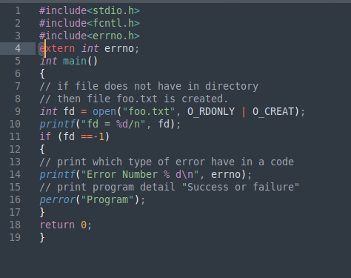 FILE: 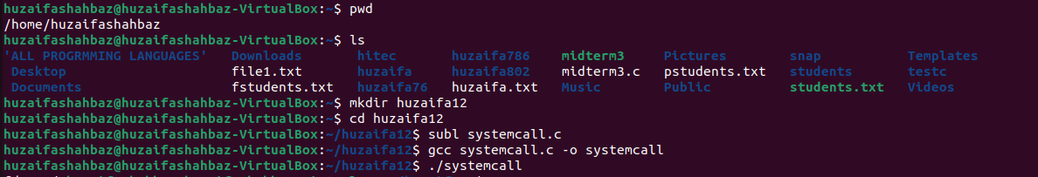OUTPUT: CLOSE CALL CODE: 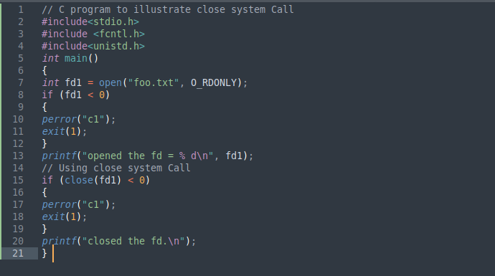
FILE:
OUTPUT: 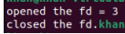
CLOSE SYSTEM CALL CODE:
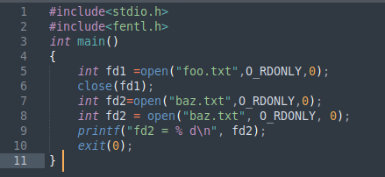 FILE: OUTPUT: CLOSE SYSTEM CALL CODE: 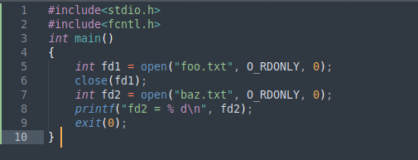 FILE: OUTPUT:

Task 2

Conclusion (write 3 to 5 lines conclusion of experiment you performed in Times New Roman 12)

